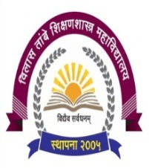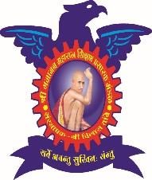

**Shri Gajanan Maharaj Shikshan Prasarak Mandal’s**

**Vilas Tambe women’s College of Education (B.ED.)**

**Dumbarwadi, Otur, Tal - Junnar, Dist - Pune - 412409**

All students of Vilas Tambe College of Education use various technologies while preparing ICT Intel Programme and Technology Based Lessons. There are different sites from where student collects information, uses many more facilities of Internet, YouTube & Computer, etc. There are number of Practical we have stored in our college.

1. <https://www.youtube.com/@DrVasudevVRaut/videos?view=0&sort=dd&shelf_id=0>
2. <https://classroom.google.com/?authuser=0>
3. <https://www.swayamprabha.gov.in/>
4. <https://shodhganga.inflibnet.ac.in/>
5. https://ess.inflibnet.ac.in/